*Imperial College of Engineering*

(RU Affiliated)

BSC Engineering 1st year 1st semester Examination ,2024

Lab Report

Course title: Computer Maintenance and Engineering Drawing

Course code: CSE1112

|  |  |
| --- | --- |
| **Submitted by:** | **Submitted to:** |
| **Name: Md,Rashidul Islam Zidan** | **Aparna Haldar** |
| **Roll:23109** | **Lecturer, Department of Computer Science & Engineering** |
| **Session:2023-24** | **Imperial College of Engineering** |

Date: 14/12 /2024

# **INDEX**

|  |  |  |
| --- | --- | --- |
| **LAB NO** | **Content** | **Page** |
| 01 | Install different types of Operating System such as Windows 10 | 3-4 |
| 02 | Install different types of application software and utilities software. | 5-6 |
| 03 | Assemble different  parts of a computer |  |
| 04 | Partition a computer hard disk. |  |
| 05 | Fault findings Detect hardware related problems in CPU and fine the solution. |  |
| 06 | Getting familiar with DOS and its commands. |  |

**LAB:03**

**Install different types of Operating System such as Windows 10**

1. Download Windows 10 ISO :Visit the official Microsoft website or use the Media Creation Tool to download the Windows 10 ISO file.
2. Create Bootable Media :Use a USB drive or DVD to create bootable media with the Windows 10 ISO file. You can use tools like Rufus for USB drives.
3. Boot from Bootable Media: Insert the bootable USB drive or DVD into your computer. Restart your computer and enter the BIOS or UEFI settings. Change the boot order to prioritize the USB drive or DVD.
4. Install Windows 10: Follow the on-screen instructions to install Windows 10. Choose your language, time, currency, and keyboard preferences. Enter your product key or skip this step if you're using Windows 10 Home edition.
5. Partitioning : Choose the partition where you want to install Windows 10 or create new partitions if necessary . Format the partition and proceed with the installation.
6. Configuration : Customize settings like region, language, account setup, and privacy options during the installation process.
7. Completion: Once the installation is complete, your computer will restart, and you'll be prompted to set up your user account.
8. Updates and Drivers: After installation, install any pending updates and drivers to ensure optimal performance.

**Other Operating Systems:**

For other operating systems like Linux distributions or macOS, the installation process will differ. You'll typically need to download the ISO file, create bootable media, boot from it, and follow the on- screen instructions specific to that OS.

Always ensure to back up your important data before installing a new operating system, as the installation process may involve partitioning or formatting your disk.

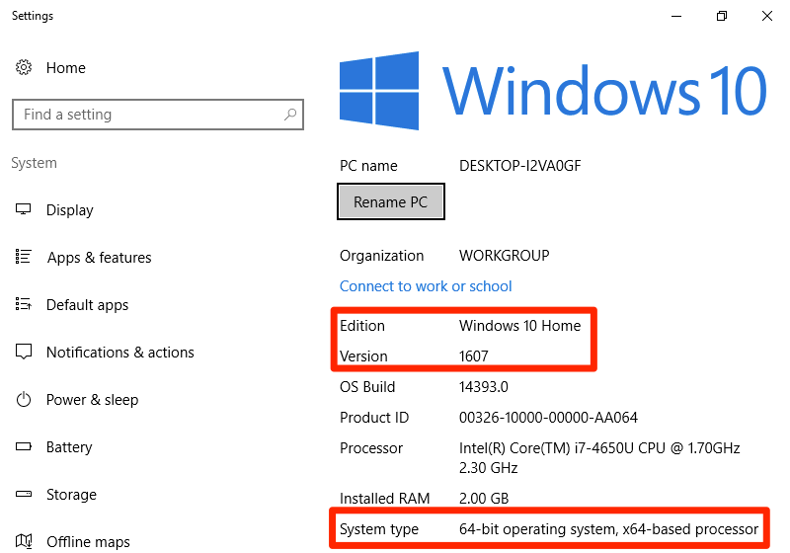

Windows 10

### **LAB:04**

**Partition a computer hard disk:**

* 1. Open Disk Management (Windows) or Disk Utility (macOS).
  2. Select Disk: Choose the disk you want to partition.
  3. Shrink/Partition: Shrink an existing partition or create a new one.
  4. Format: Format the new partition with a file system (e.g., NTFS for Windows, APFS for macOS).
  5. Apply Changes: Confirm and apply the changes

Remember to back up important data before partitioning.

